**HIWFRS Safety Plan consultation toolkit**

* [Consultation web page](https://www.hantsfire.gov.uk/community/engagement-hub/draft-safety-plan-2025-30-consultation/)
* [YouTube video](https://www.youtube.com/watch?v=VEmAWTNEwXQ)
* [Survey](https://www.smartsurvey.co.uk/s/FWTQE5/)

**Facebook**

* Click the link to access and then share our Facebook post on your own profile -   
  [Hampshire and Isle of Wight Fire and Rescue Service | Facebook](https://www.facebook.com/HampshireIOWFireService/videos/have-your-say/1084519786408364/?rdid=0rRHfpXVE2gvMBv3)

**X**

* Click the link to access and then re-post our Tweet on your own X profile -   
  [Hampshire and Isle of Wight Fire and Rescue Service | X](https://x.com/HantsIOW_fire/status/1844002332176199701)

**Web / bulletin content**

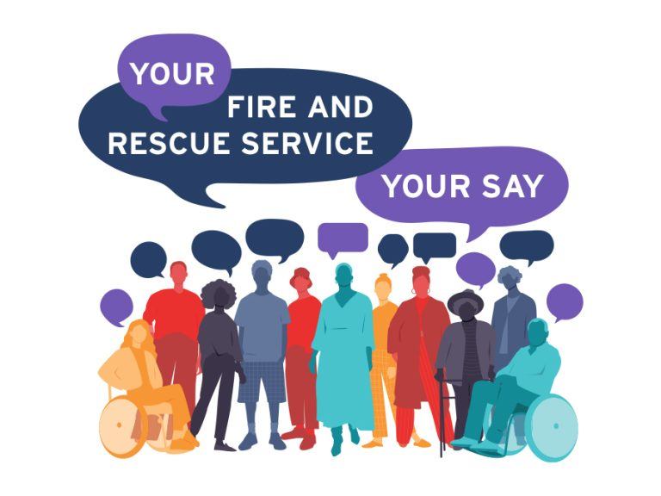

**Your views matter**

We are excited to announce the launch of our public consultation for the [Draft Safety Plan 2025-2030](https://www.hantsfire.gov.uk/wp-content/uploads/2024/10/Safety-Plan-2025-2030-for-consultation-final-10102-NEW-1.pdf). Your input is invaluable as we work to enhance the safety of our Hampshire and Isle of Wight communities.

**Get Involved!**

* [Find out more](https://www.hantsfire.gov.uk/community/engagement-hub/draft-safety-plan-2025-30-consultation/)
* Read our [Draft Safety Plan 2025-2030](https://www.hantsfire.gov.uk/wp-content/uploads/2024/10/Safety-Plan-2025-2030-for-consultation-final-10102-NEW-1.pdf)
* Watch our informative [video](https://www.youtube.com/watch?v=VEmAWTNEwXQ)
* [Take the survey](https://www.smartsurvey.co.uk/s/FWTQE5/)